**Architecture of Application**

1. **Monolithic App:**

a. Monolithic Python application using Flask.

b. The application will have 2 services:

i. User Service: Add, remove, view users.

ii. Product Service: Add, remove, view products.

c. SQLite as the database for this monolithic app.

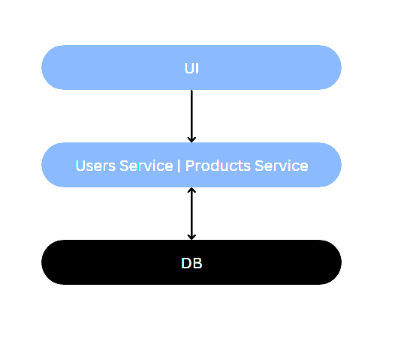

1. **Microservices:**

a. Split the monolithic app into two separate microservices.

b. Each microservice will have its own Flask app and SQLite database.

c. UI for each microservice.

